**Excel Assignment - 8**

1. What do you mean by AutoComplete feature in Excel and what are the benefits of using this feature?

Answer:

AutoComplete helps you quickly insert functions and arguments while minimizing typing and syntax errors.AutoFill is a very useful Excel feature. It allows you to create entire columns or rows of data which are based on the values from other cells.

1. Explain working with workbooks and working with cells.

Answer: An Excel file, often referred to as a workbook, contains one or more spreadsheets, or worksheets. Each box in the worksheet area is referred to as a cell. Each cell has a cell address, which is composed of a column reference and a row reference. The letters across the top of the worksheet make up the column reference

1. What is fill handle in Excel and why do we use it?

Answer: Fill Handle is a feature in Excel that enables us to auto-complete a list in a row/column by simply dragging it by mouse. A basic understanding of fill handle in Excel could save our time and make us productive.

1. Give some examples of using the fill handle.

Answer:

Example for fill handle is –

Step1: Write data you want to fill.

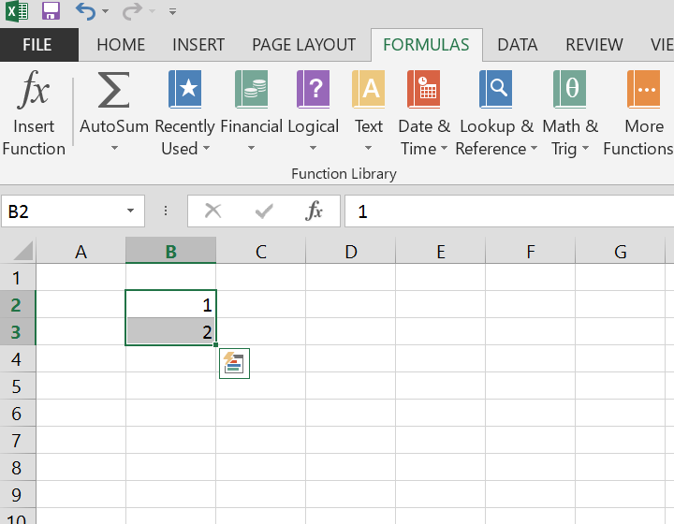

Step 2: Drag the cell till the cell you want the result.

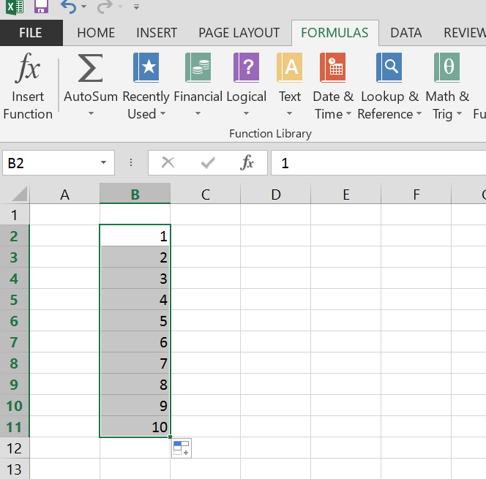

1. Describe flash fill and what the different ways to access the flash fill are.

Answer: Flash Fill automatically fills data when it senses a pattern.

For example, Flash Fill to separate first and last names from a single column, or combine first and last names from two different columns.

1. Extract first name and last name from the mail id and then from the address column, extract the city, state, and pin code using the flash fill. Given below is an example of the columns you have to create. Paste the screenshot of what you have created using the flash fill command. Example: Mail Id, Address, First name, Last name, State, City, Pin code

Answer: I have added the screen shot of the table made using flash fill.

